**Practical-1**

**Aim:** **Write a program to convert rupees to dollar. 60 rupees=1 dollar.**

class r2d {

float rs,dollar;

void convert(float rs){

dollar = rs/60;

System.out.println("Dollar is " +dollar);

}

}

class d2r {

float rs,dollar;

void convert(float dollar){

rs = dollar * 60;

System.out.println("Rs is " +rs);

}

}

class conversion {

public static void main(String args[]){

r2d r = new r2d();

d2r d = new d2r();

r.convert(120);

d.convert(2);

}

}

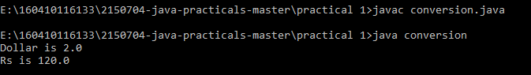

**Aim:** **Write a program that calculates percentage marks of the student if marks of 6 subjects are given.**

import java.util.*;

class inpt

{

float s1[]= new float [6];

float n,sum=0;

void inp()

{

Scanner value= new Scanner(System.in);

System.out.println("No of Subjects you want to enter marks for:");

n=value.nextFloat();

if(n!=6)

{

System.out.println("ERROR");

}

else

{

System.out.println("Enter Marks of Subjects:");

for(int i=0;i<n;i++)

{

s1[i]=value.nextFloat();

}

}

}

void marks()

{

float sum=0,per;

for(int i=0;i<6;i++)

{

sum=sum+s1[i];

}

per=sum/6;

System.out.println("Percent=" +per);

}

}

class abc

{

public static void main(String args[])

{

float a;

inpt ABC= new inpt();

ABC.inp();

ABC.marks();

}

}

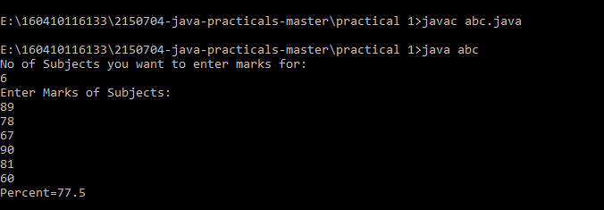

**Practical-2**

**Aim:** **Write a program to enter two numbers and perform mathematical operations on them.**

import java.util.*;

class input{

public static void main(String args[]){

int i;

String a;

Scanner AB = new Scanner(System.in);

a = AB.nextLine();

int l = a.length();

char def[] = new char[a.length()];

System.out.println("Length is = " +l);

System.out.println("Half of string is :" +a.substring(l/2));

a.getChars(0, a.length(),def,0);

for(i=a.length()/2;i<a.length();i++){

System.out.print(" "+def[i]);

}

char x[] = a.toCharArray();

for(i=x.length/2;i<x.length;i++){

System.out.println(" "+x[i]);

}

}

}

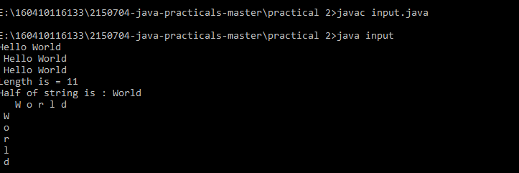

**Aim:** **Write a program to find length of string and print second half of the string.**

import java.util.*;

public class Cla

{

public static void main(String[] args)

{

int a,b;

float res;

Scanner scan=new Scanner(System.in);

System.out.print("enter the value of a");

a=scan.nextInt();

System.out.println("enter the value of b");

b=scan.nextInt();

res=a+b;

System.out.println("addition=="+res);

res=a-b;

System.out.println("subtraction=="+res);

res=a*b;

System.out.println("multiplication=="+res);

res=(float)a/(float)b;

System.out.println("division=="+res);

}

}

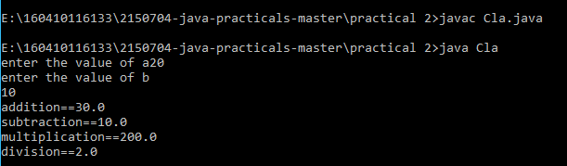

**Practical-3**

**Aim:** **Write a program to accept a line and check how many consonants and vowels are there in line**

import java.util.*;

class s1{

public static void main(String args[]){

int i;

String a;

Scanner AB = new Scanner(System.in);

a = AB.nextLine();

System.out.println(" " +a);

for(i=0;i<a.length();i++){

if(a.charAt(i)=='a' || a.charAt(i) == 'e'|| a.charAt(i) == 'i'|| a.charAt(i) == 'o'|| a.charAt(i) == 'u'|| a.charAt(i) == 'A'|| a.charAt(i) == 'E'|| a.charAt(i) == 'I'|| a.charAt(i) == 'O'|| a.charAt(i) == 'U'){

System.out.println("Vowels are " +a.charAt(i));

}

else{

System.out.println("Consonants are " +a.charAt(i));

}

}

}

}

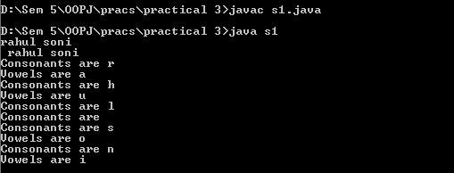

**Aim: Write a program to count the number of words that start with capital letters**

import java.util.*;

class r1{

public static void main(String args[]){

int i,word=0,space=0;

String a;

Scanner AB = new Scanner(System.in);

a = AB.nextLine();

System.out.println(" " +a);

for(i=0;i<a.length();i++){

char ch = a.charAt(i);

if(ch == 32){

space++;

}

if (Character.isUpperCase(ch)

&& (i == 0 || Character.isWhitespace(a.charAt(i - 1)))) {

word++;

}

}

System.out.println("Total capital words" +word);

System.out.println("Total spaces" +space);

}

}

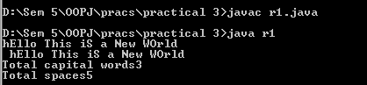

**Practical-4**

**Aim:** **Write a program to find that given number or string is palindrome or not.**

import java.util.*;

class input{

String name = "";

void set(String a){

name = a;

}

void get(){

System.out.println(" " +name);

}

}

class palindrome {

public static void main(String args[]){

String s1,s2;

int i;

input a1 = new input();

Scanner AB = new Scanner(System.in);

s1 = AB.nextLine();

a1.set(s1);

a1.get();

s2 = "";

for(i=s1.length()-1;i>=0;i--){

s2 = s2+s1.charAt(i);

}

if(s2.equalsIgnoreCase(s1)){

System.out.println("Palindrome");

}

else{

System.out.println("Not Palindrome");

}

}

}

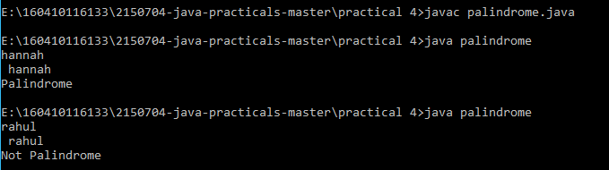

**Aim:** **Create a class which asks the user to enter a sentence, and it should display count of each vowel type in the sentence. The program should continue till user enters a word “quit”. Display the total count of each vowel for all sentences.**

import java.util.*;

class quit{

public static void main(String args[]){

String s1,s2;

int i,count=0;

Scanner AB = new Scanner(System.in);

s1 = AB.nextLine();

while(AB.hasNext()){

s2 = AB.nextLine();

if(s2.equalsIgnoreCase("quit"))

break;

s1 = s1+s2;

}

System.out.println("Ans: " +s1);

for(i=0;i<s1.length();i++){

if(s1.charAt(i)=='a' || s1.charAt(i) == 'e'|| s1.charAt(i) == 'i'|| s1.charAt(i) == 'o'|| s1.charAt(i) == 'u'|| s1.charAt(i) == 'A'|| s1.charAt(i) == 'E'|| s1.charAt(i) == 'I'|| s1.charAt(i) == 'O'|| s1.charAt(i) == 'U'){

count++;

}

}

System.out.println("Number of vowels " +count);

}

}

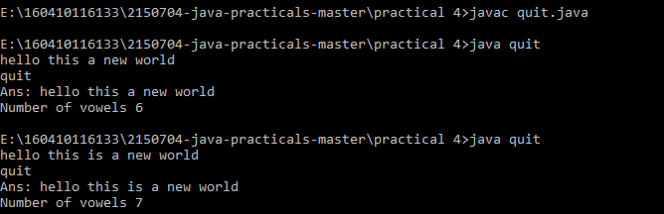

**Practical-5**

**Aim:** **Write an interactive program to print a string entered in a pyramid form. For instance, the string “stream” has to be displayed as follows:**

**S**

**S t**

**S t r**

**S t r e**

**S t r e a**

**S t r e a m**

import java.util.*;

class pattern{

public static void main(String args[]){

String s1,s2="";

int i,j,k=50;

Scanner AB = new Scanner(System.in);

s1 = AB.nextLine();

for(i=0;i<s1.length();i++){

for(j=0;j<k;j++){

System.out.print(" ");

}

k=k-1;

for(j=0;j!=i+1;j++){

System.out.print(" "+s1.charAt(j));

}

System.out.println();

}

}

}

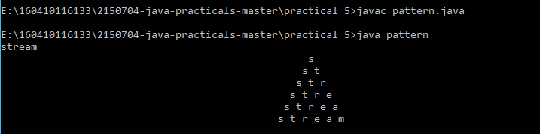

**Aim:** **Write an interactive program to print a diamond shape. For example, if user enters the number 3, the diamond will be as follows:**

**\***

**\* \***

**\* * \***

**\* \***

**\***

import java.util.*;

class pattern2{

public static void main(String args[]){

String s1,s2="";

int i,j,k=50;

Scanner AB = new Scanner(System.in);

s1 = AB.nextLine();

for(i=0;i<s1.length();i++){

for(j=0;j<k;j++){

System.out.print(" ");

}

k=k-1;

for(j=0;j!=i+1;j++){

System.out.print(" "+s1.charAt(j));

}

System.out.println();

}

k=52-s1.length();

for(i=s1.length();i!=0;i--){

for(j=0;j!=k;j++){

System.out.print(" ");

}

k=k+1;

for(j=i-1;j!=0;j--){

System.out.print(" "+s1.charAt(j));

}

System.out.println();

}

}

}

